**Experiment no – 01 (A)**

**Aim:** Write the program for the following: (by using control statements and control structure)

(A). Create a program that asks the user to enter their name and their age. Print out a message addressed to them that tells them the year that they will turn 100 years old.

**Theory: -**

**Practical Implementation**:-

**Code**:-

*#* Create a program that asks the user to enter their name and their age. Print out a message addressed to them that tells them the year that they will turn 100 years old.

import datetime

name = input("Hello! Please enter your name: ")

print("Hello " + name)

age = int(input("Enter your age: "))

year_now = datetime.datetime.now()

# print(year_now.year)

print("You will turn 100 in " + str(int(100-age) + int(year_now.year)))

**Output:**

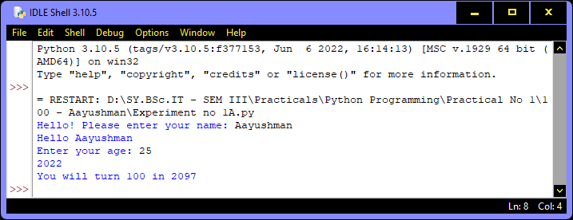

**Conclusion:** The entered string were identified as NFA or not based of the provided state diagram.